Proposed 2009 Gypsy Moth Suppression Treatment Areas

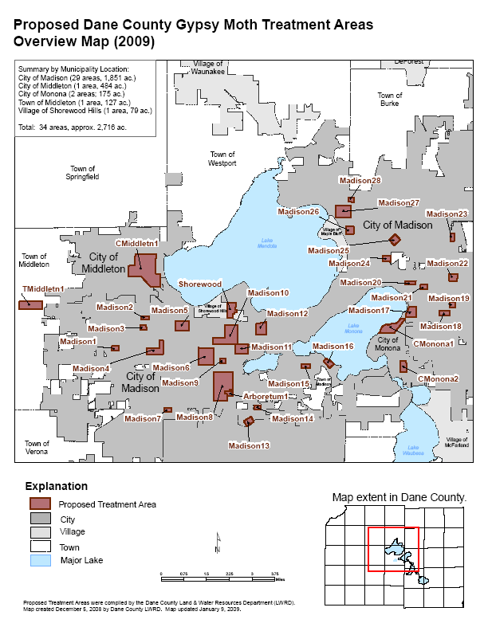

City of Madison

Madison1: Westward Woods-Bordered by Randolph Drive on the east and S. High Point Drive on the west. Extends to Ganser Way in the southern portion of the block and to Westward Way in the north. Bisected by Mineral Point Road.

Madison2: Old Sauk Road-Bordered by Sauk Ridge Trail on the east and Everglade Drive on the west. Bisected by Old Sauk Road.

Madison3: Parkwood Glen-Bordered by Everglade Drive on the west and Acadia Drive on the north. Extends to Everglade Circle on the south. Cuts across N. Yellowstone Drive and Shiloh Drive on the east.

Madison4: Faircrest-This block is L-shaped. Covers the intersection of Grand Teton Plaza and S. Yellowstone Drive, with Mineral Point Road as a northern border. Extends several blocks south of Mineral Point Drive as well as east of Island Drive. Covers the westernmost portion of Driftwood Avenue.

Madison5: Glen Oak Hills Park-Bordered by Green Lake Pass on the east and Glen Highway on the west. This block’s southern boundary is just north of Regent Street. Its northern boundary is just south of Old Middleton Road.

Madison6: Oak Park Heights-Bordered by S. Midvale Boulevard on the east and Berwyn Drive/Caldy Place on the west. The southern boundary is just south of Tokay Boulevard. In the north, this block is bordered by Mineral Point Road.

Madison7: Meadowood-Bordered by Raymond Road on the north and Cameron Drive on the west. Bisected by Leland Drive.

Madison8: Nakoma-Bordered by S. Midvale Boulevard on the east and the Beltline Highway on the south. The northern edge of this block extends straight east from Rolla Lane to Huron Hill. The eastern boundary of this block is within the UW-Arboretum.

Madison9: Westmorland Park-Bordered by Park Lane on the east, Tokay Boulevard on the south, and Saint Clair Street on the north. This block’s western border extends just past Gately Terrace.

Madison10: Hoyt Park-This block is L-shaped. Its eastern border is just east of Franklin Avenue. It is bordered by Kendall Avenue/McKinley Street to the north and Hamersley Avenue to the south. In the west, the block extends to S. Midvale Boulevard.

Madison11: Forest Hill-This block covers predominantly non-residential property. It is bordered in the east by Virginia Terrace/Sheldon Street. It extends to Sprague Street in the southeast and across Speedway Road in the northeast.

Madison12: University Heights-Bordered by N. Spooner Street on the east, N. Allen Street on the west, Rowley Avenue on the south, and University Avenue on the north.

Madison13: Todd Drive-Extends southwest from the intersection of Todd Drive and Post Road. Bisected by Post Road and Irvington Way.

Madison14: Ardsley Lane-Extends just west of Ashford Lane. Bordered by Greenway View on the south and McDivitt Road on the north. Bisects Ardsley Lane and Ardsley Circle. The block’s eastern border is a large parking area.

Madison15: Goodman Park-Bordered by Spruce Street on the north. Covers the intersection of Cedar Street and Hickory Street. This block’s eastern border is within park.

Madison16: Olin Park-Within Olin Park between John Nolin Drive and Lake Monona.

Madison17: Allis School-Bordered on the west by Monona Drive and bisected by Buckeye Road and Jerome Street. Extends to Lake Edge Boulevard to the north, Quaker Circle to the south and to the intersection of Hegg Avenue and Davies Street to the east.

Madison18: Acewood Park-Bordered by Twilight Trail on the east and Eldorado Lane on the north. Encompasses areas of Academy Drive and Starker Avenue.

Madison19: Elvehjem School-Covers the intersection of Ironwood Drive and Meadowlark Drive. Bordered on the west by Woodvale Drive and Woodvale Circle.

Madison20: Schenk School-Bordered on the east by Buckingham Lane, on the south by Tulane Avenue, and on the north by Wilshire Lane. Bisected by Schenk Street. Covers the property of Schenk School.

Madison21: St. Dennis School- Bordered by Atlas Avenue on the east and Dempsey Road on the West. Bisected by Stoughton Road.

Madison22: Kennedy Park-Bordered by Coach House Drive on the east and Sudbury Way on the north. Extends almost to Retana Drive in the south and almost to Meadowlark Drive in the west.

Madison23: Crescent Oaks-Covers the intersection of N. Thomson Drive and Esker Drive and all of Crescent Oaks Drive and Crescent Oaks Court.

Madison24: Worthington Park-Bordered by Rethke Avenue on the east. Extends past Webb Avenue on the north and past Worthington Avenue on the south. Extends almost to Clyde Gallagher Avenue on the west.

Madison25: Carpenter-Ridgeway-Bisected by E. Washington Avenue. Extends to Wright Street in the northeast and to Powers Avenue in the southwest. Covers the intersection of Grover Street and Quincy Avenue.

Madison26: Sherman School-Bordered by Huxley Street on the east and Freemont Avenue in the west. Extends to Schlimgen Avenue in the north and Boyd Avenue in the south. Bisected by N. Sherman Avenue.

Madison27: Warner Park-Covers areas of Warner Park and residential properties to the immediate southeast. Bisected by N. Sherman Avenue and bordered by Ruskin Street on the east.

Madison28: Berkley Park-Bordered by Dryden Drive on the east and N. Sherman Avenue on the west. Extends just past Browning Road on the south. Bisected by Thackeray Road.

City of Monona

CMonona1: Eastern border of treatment area runs along Shore Acres Road from
Midmoor Road in the southeast to Monona Drive in the northeastern corner of the treatment area. Southern border is located between Greenway Road and W. Dean Avenue. Bordered on the northwest by Lake Monona.

CMonona2: Bordered by Monona Drive on the east and Sylvan Lane on the
west. Bordered by Kings Row on the south and Frost Woods Road on the north.

City of Middleton

CMiddletn1: Bordered by Allen Boulevard on the east and Bristol Street on the
west. Bordered by Hubbard Avenue on the south, extending directly southeast to
Countryside Lane. Bordered by Donna Drive on the north.

Town of Middleton

TMiddletn1: Extends east from the intersection of Blackhawk Road and Twin
Valley Road. Bisected by Blackhawk Road.

Village of Shorewood Hills

Shorewood: Bordered by University property on the east. Extends to University
Avenue in the south and almost to Haight Road in the north. Extends just past Amherst Drive and Swarthmore Court in the west.

University of WI Arboretum

Arboretum: Adjacent to Madison 8. Bisected by McCaffrey Drive within
Arboretum property.

